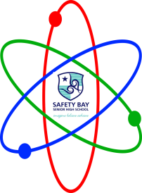
I can |  | Redox Year 12 Chemistry 2023 | Check | Teacher initial
 |  | Understand oxidation involves the loss of electrons from a chemical species, and reduction involves the gain of electrons by a chemical species; these processes can be represented using half-equations and redox equations
 |  | Define displacement reactions, acid-base reaction, disproportionation and electrolytic reactions
 |  | Identify the species being oxidised and reduced in a redox reaction using oxidation numbers
Identify the oxidising and reducing agents in a reaction.
Explain the reason for my choice of answers

 |  | Can write fully balanced ionic equations, including state symbols of substances involved in the reaction
 |  | Describe oxidation-reduction (redox) reactions involve the transfer of one or more electrons from one species to another
 |  | Write the oxidation and reduction half-equations, and a balanced overall redox equation.
 |  | Understand electrolytic cells use an external electrical potential difference to provide the energy to allow a non-spontaneous redox reaction to occur
 |  | Understand electrochemical cells, including galvanic and electrolytic cells, consist of oxidation and reduction half-reactions connected via an external circuit through which electrons move from the anode (oxidation reaction) to the cathode (reduction reaction)
 |  | Describe the use of electrolysis in electrolytic refining, including for purification of copper, and metal electroplating, including for silver
 |  | Understand the characteristics of a fuel cell.
 |  | Understand the difference between a primary and secondary cell.
 |  | Understand the reaction occurring between water and metals with the help of balanced equations.
 |  | Calculate cell voltage using standard reduction potential values
 | Comment

